Date access: 2020-03-09

<http://wjw.beijing.gov.cn/wjwh/ztzl/xxgzbd/gzbdyqtb/202001/t20200130_1621739.html>

From 17:00 to 23:00 on the 25th, there were 10 new cases of pneumonia infected with new coronavirus in the city, and 49 people were treated in the hospital

Date: 2020-01-26 Source: Beijing Municipal Commission of Health

From 17:00 to 23:00 on January 25th, 10 new cases of pneumonia infected by the new coronavirus in this city have been sent to designated medical institutions for treatment. At present, 49 people are being treated in the hospital, with one severe case.

From 17:00 to 23:00 on January 25, a total of 51 confirmed cases were reported in the city, including 1 in Dongcheng District, 5 in Xicheng District, 8 in Chaoyang District, 10 in Haidian District, 3 in Fengtai District, and 1 in Shijingshan District. There were 4 cases in Tongzhou District, 1 case in Shunyi District, 2 cases in Daxing District, 5 cases in Changping District, and 11 cases came from overseas.

**从25日17时至23时，本市新增10例新型冠状病毒感染的肺炎病例，在院治疗49人**

日期：2020-01-26 来源：北京市卫生健康委‍

        从1月25日17时至23时，本市新增10例新型冠状病毒感染的肺炎病例，均已送至定点医疗机构进行救治。目前在院治疗49人，有一例重症。

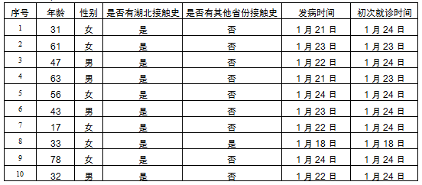

        从1月25日17时至23时，本市累计确诊病例51例，其中东城区1例、西城区5例、朝阳区8例、海淀区10例、丰台区3例、石景山区1例、通州区4例、顺义区1例、大兴区2例、昌平区5例，外地来京人员11例。